TABLE OF CONTENT
- Introduction…………………………………………………………………………………………2
- Problem Description……………………………………………………………………………..3
- System Explanation & Workflow Architectural Design………………………………4
3.1 The Data Processing Lifecycle………………………………………………………….4
3.2 Core Operational Methods…………………………………………………………….…4
- Structured Programming Application……………………………………………………...5
4.1 Modular Decomposition…………………………………………………………………..5

- Alignment with UN Sustainable Development Goals (SDG 8)……………………6
- Complete Clean Source Code……………………………………………………………….7
- System Screenshot……………………………………………………………………………..8
- Git hub evidence screenshot………………………………………………………………..9
- Conclusion…………………………………………………………………………………………10

1.Introduction
In developing economies like Sierra Leone, Small and Medium Enterprises (SMEs) function as the bedrock of macroeconomic stability, wealth creation, and community employment. Despite their critical importance, the vast majority of micro-retailers, local market traders, and small-scale business operators across the country navigate their daily transactions without formal digital accounting frameworks. Instead, operational financial tracking is predominantly performed using traditional, physical ledger books.
While accessible, paper-based tracking introduces a cascade of systemic vulnerabilities, including catastrophic data loss from physical damage, manual mathematical calculation errors, and an inability to reconcile compound variables such as localized overhead costs and customer discounts. Without structured mathematical visibility, local operators frequently fall victim to the "Margin Illusion"—a phenomenon where high transaction volumes are falsely conflated with sustainable profitability, masking underlying deficits and miscalculated unit margins.
To bridge this critical digital divide and support the formalization of local business models, the Sierra Leone SME Tracker has been engineered. This desktop-based workstation provides a low-footprint, high-reliability computational tool explicitly tailored to accommodate local hardware constraints and structural market dynamics. By translating standard managerial accounting frameworks into an intuitive, automated software interface, the system replaces manual financial guesswork with precise, programmatic calculation. Operating natively with the Sierra Leonean Leone ($Le$), the tracker empowers small business owners to gain a transparent, real-time understanding of their net profit margins, accurately balance operating expenses, and secure long-term business continuity.

2.Problem Description
In Sierra Leone, Small and Medium Enterprises (SMEs) represent the backbone of the domestic economy, employing a substantial segment of the population. However, a significant operational hurdle for these businesses is the lack of formalized, accessible, and automated financial tracking frameworks. Many micro-retailers and local market traders rely on physical ledger books, which are highly vulnerable to loss, damage, structural miscalculations, and geometric tracking errors.
Without clean visibility into overhead expenses, discounts offered, and base unit margins, operators face an inability to calculate true profit margins vs gross cash intake. The specific challenges targeted by this system include:

  - The Margin Illusion: Mistaking high raw transaction volumes for healthy business performance while neglecting underlying operating expenses and compounding discounts.
- Manual Math Faults: Inaccuracies in multi-variable equations containing combinations of gross quantities, product discounts, and localized overhead parameters.
- Lack of Real-time History: Inability to view chronological multi-product performance over a single daily shift or tracking session.

The Sierra Leone SME Tracker bridges this digital divide by offering a low-footprint, intuitive desktop workstation engineered for local hardware constraints while computing financial outcomes with programmatic precision

3.System Explanation & Workflow Architectural Design
The system is architected as a lightweight standalone graphical desktop application using Python's native Tkinter ecosystem. The programmatic pipeline operates through clear input capturing, data validation, localized arithmetic execution, state preservation, and output compilation.

3.1The Data Processing Lifecycle
The processing logic models standard managerial accounting frameworks tailored to micro enterprises. It collects structural fields, applies conditional checking, and uses the following systemic mathematical definitions:
- Total Cost Outlay: TC = Q × CP
- Gross Revenue: GR = Q × SP
- Net Revenue: NR = GR − D
- Total Net Profit: P_net = NR − (TC + E)
3.2 Core Operational Methods
  - calculate_report(): Extracts user text strings from graphical input fields, forces structural parsing via int() and float() within safe try-except boundaries, computes profit margins, appends metrics to an active runtime list state, and flushes formatted results out onto a monochromatic terminal emulation view.
  - clear_fields(): Purges existing variable states within UI fields, resets default values back to 0 for discounts and operating expenses, and resets the terminal to an active baseline greeting message.
  - view_records(): Loops over the state storage array to construct an audit ledger summarizing performance metrics over an active active execution session

4.Modular Decomposition
Instead of relying on a monolithic layout, the system isolates user interactions, functional operations, and presentation states. Each operation is packaged inside clear, single-responsibility functions (calculate_report, clear_fields, view_records, create_hover_button). This abstraction guarantees that modifications to the calculations will not break or decouple user graphical window rendering logic.
A primary rule of structured programming is maintaining program execution stability when given corrupted data. The system enforces defensive bounds checks using try-except control logic blocks. This design shields the application from runtime memory crashes or calculation halts due to bad user input (such as alphabetic strings passed into monetary fields or blank descriptions), safely alerting users via dialog message boxes while keeping the program alive.

5.Alignment with UN Sustainable Development Goals (SDG 8)
UN SDG Target 8.3: Promote Development-Oriented Policies "Promote development-oriented policies that support productive activities, decent job creation, entrepreneurship, creativity and innovation, and encourage the formalization and growth of micro-, small- and medium-sized enterprises...

Many micro-retailers fail within their initial years due to poor overhead oversight. By providing localized tools that handle currency scaling flawlessly (using Sierra Leonean Leones - Le), business owners move from intuitive guesswork to data-backed financial choices. They can see exactly how discounts impact net margins, allowing them to optimize pricing strategies safely

6.Complete Clean Source Code
- import tkinter as tk
- from tkinter import messagebox

- # ==========================================
- # MODERN COLOR PALETTE & STYLES
- # ==========================================
- BG_APP = "#000000" # Soft light grayish-blue background
- BG_CARD = "#FFFFFF" # Crisp white for input areas
- TEXT_DARK = "#FF0000" # High-contrast dark slate for text
- TEXT_LIGHT = "#7F8C8D" # Muted gray for secondary text
- THEME_BLUE = "#2980B9" # Corporate Header Blue
- TERM_BG = "#1E272E" # Dark Terminal Background
- TERM_FG = "#00D2D3" # Bright Cyan Terminal Text

- # Button Colors (Normal / Hover)
- BTN_CALC = ("#27AE60", "#2ECC71") # Emerald Green
- BTN_CLEAR = ("#F39C12", "#F1C40F") # Amber Orange
- BTN_VIEW = ("#2980B9", "#3498DB") # Modern Blue
- BTN_EXIT = ("#C0392B", "#E74C3C") # Crimson Red

- # ==========================================
- # SYSTEM LOGIC & FUNCTIONS
- # ==========================================
- sales_records = []

- def calculate_report():
- try:
- product_name = entry_name.get().strip()
- if not product_name:
- messagebox.showerror("Input Error", "Product name cannot be empty.")
- return

- quantity = int(entry_qty.get())
- cost_price = float(entry_cost.get())
- selling_price = float(entry_sell.get())
- discount = float(entry_discount.get())
- expenses = float(entry_expenses.get())

- if quantity < 0 or cost_price < 0 or selling_price < 0 or discount < 0 or expenses < 0:
- messagebox.showerror("Input Error", "Numeric values must be positive.")
- return

- # Processing Logic
- total_cost = quantity * cost_price
- total_revenue = quantity * selling_price
- net_revenue = total_revenue - discount
- final_profit = net_revenue - (total_cost + expenses)

- # Store record in history
- sales_records.append(f"[{product_name.upper()}] - Net Profit: Le {final_profit:,.2f}")

- # Formatting Output Display
- output_text.delete("1.0", tk.END)
- report = (
- f"==================================================\n"
- f" SMALL BUSINESS SALES REPORT (SDG 8) \n"
- f"==================================================\n"
- f" Product Name : {product_name.upper()}\n"
- f" Quantity Sold : {quantity} Units\n"
- f"--------------------------------------------------\n"
- f" Total Cost Outlay : Le {total_cost:,.2f}\n"
- f" Gross Revenue : Le {total_revenue:,.2f}\n"
- f" Discount Applied : Le {discount:,.2f}\n"
- f" Operating Expenses : Le {expenses:,.2f}\n"
- f"==================================================\n"
- f" TOTAL NET PROFIT : Le {final_profit:,.2f}\n"
- f"=================================================="
- )
- output_text.insert(tk.END, report)

- except ValueError:
- messagebox.showerror("Format Error", "Please ensure Quantity is a whole number and prices are numeric.")

- def clear_fields():
- """Resets all input fields to their default state."""
- entry_name.delete(0, tk.END)

- entry_qty.delete(0, tk.END)
- entry_cost.delete(0, tk.END)
- entry_sell.delete(0, tk.END)

- entry_discount.delete(0, tk.END)
- entry_discount.insert(0, "0")

7.System Screenshot

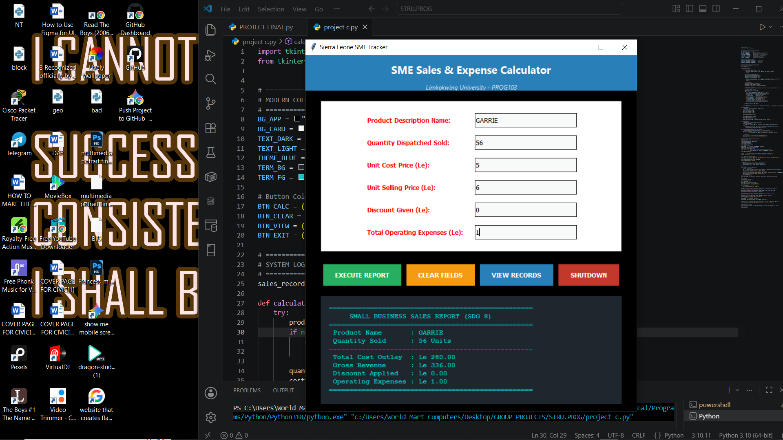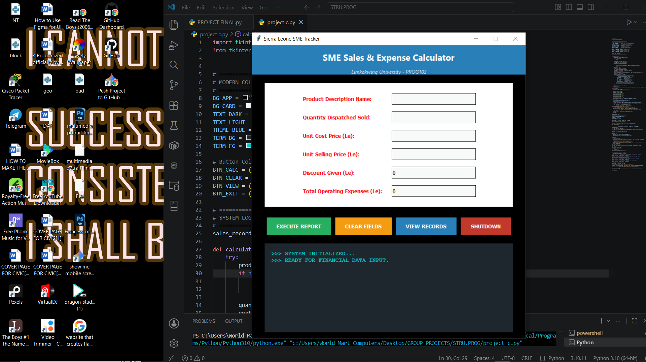

8.Git hub evidence screenshot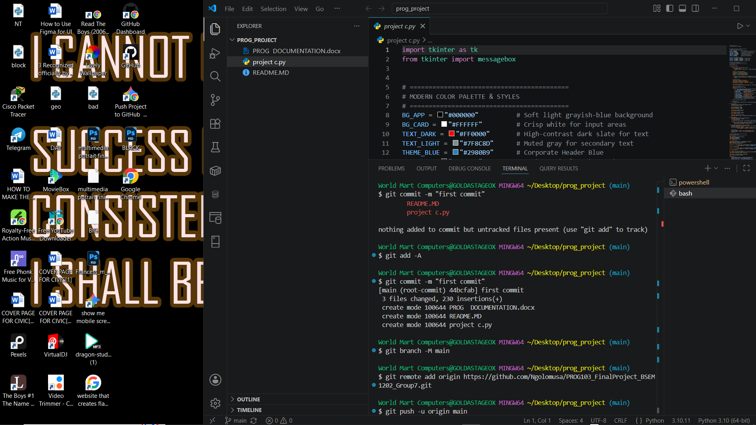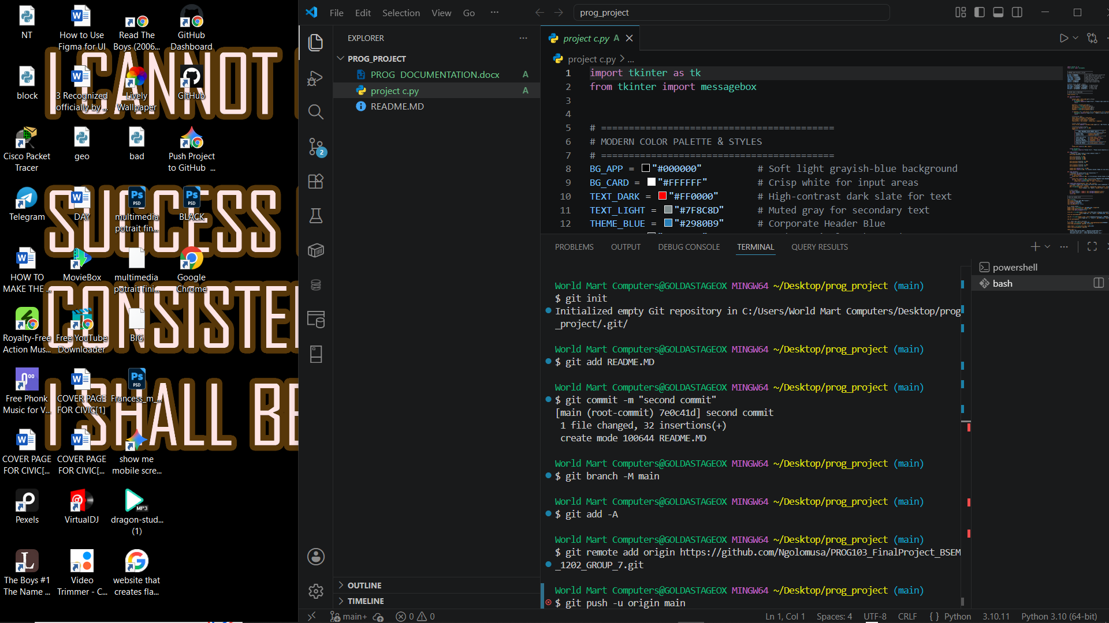
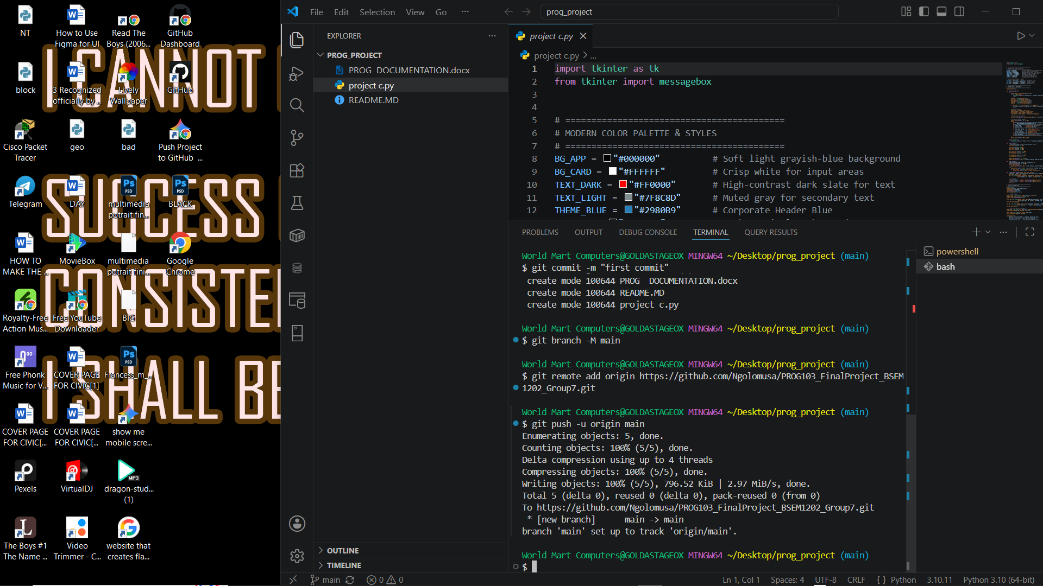

9.Conclusion
The development of the Sierra Leone SME Tracker demonstrates how targeted, lightweight software engineering can solve foundational operational challenges for micro-enterprises in emerging markets. By replacing error-prone manual ledgers with an automated, rule-based computational desktop application, the system effectively mitigates the mathematical faults, margin illusions, and data vulnerabilities that historically stifle the survival rate of local businesses. Through a clean separation of concerns and robust error-handling mechanisms, the application provides an enduring, crash-resistant environment capable of operating efficiently on entry-level, resource-constrained hardware configurations.
Furthermore, this software system represents a direct, actionable technical implementation of the United Nations Sustainable Development Goal 8 (Target 8.3), which advocates for the formalization, structural growth, and operational resilience of micro-, small-, and medium-sized enterprises. By contextualizing core accounting workflows within the local economic framework—including native currency configuration and multi-variable overhead tracking—the application shifts business management from intuitive speculation to data-backed financial strategy. Ultimately, the Sierra Leone SME Tracker establishes a scalable baseline for localized financial technology tools, providing operators with the analytical clarity required to optimize pricing, control expenses, and actively contribute to sustainable economic growth.

